👉 “When you open Netflix, how does it instantly know what shows or movies you’ll like?”
- Show Netflix’s “Top Picks for You” screen.

- Tell students: “This is not magic. It’s Big Data + Distributed Computing working behind the scenes.”
In Simple Distributed Computing - Means Not Putting Load on a Single machine instead of Splitting data copies in multiple machines so requests can be fulfilled by the Free machine. ( Will be covered in detail in Next Class)
- Context-setting: Netflix collects, stores, processes, and analyzes data at massive scale to deliver a personalized, smooth experience.

Section 1 – Big Data Foundations

Introduction to Big Data
  - Definition: Big Data refers to datasets so large, complex, or fast-moving that traditional systems (like Excel or relational databases) cannot process them efficiently.

Netflix Example:

    - Netflix has 270M+ global users.

    - Every click, pause, search, rewind, or rating generates logs.

    - Collectively, Netflix produces petabytes of data daily.

  - Analogy: Think of a library where instead of thousands of books, you suddenly have billions of books, videos, and notes arriving every second. You need new tools to manage it.

  - Visual: User → Netflix app → data logs → data servers.

Sources of Big Data

  - Netflix collects data from multiple sources:

- Viewing Habits – what shows/movies users watch, when, and how often.

- Search Queries – e.g., “Horror Movies 2024.”

- Interactions – likes, dislikes, ratings, skips.

- Device Logs – TV, mobile, tablet, smart speakers.

- External Data – social media buzz and trending hashtags.

  - Engagement Activity: Ask students: “Think of 5 things you do on Netflix daily. Which of these actions become data?”

  - Visual: Table → Source vs Netflix Example.

Main Challenges with Big Data

The 5 V’s of Big Data:

    - Volume: Netflix stores petabytes of watch history.

    - Velocity: Millions stream simultaneously; data flows at lightning speed.

    - Variety: Structured (tables, logs), semi-structured (JSON), and unstructured (videos, subtitles).

    - Veracity: Data can be incomplete or biased (e.g., fake reviews).

    - Value: True business value comes from insights (recommendations → retention).

  - Visual: Infographic of 5 Vs with Netflix-specific examples.

The Core 3 V’s of Big Data
  - Volume: Over 125M+ hours streamed daily.

  - Velocity: Recommendations update in under a second.

  - Variety: Data includes movies, TV shows, subtitles, trailers, thumbnails, ratings.

  - Netflix Analogy: It’s like running a restaurant with 100M+ customers ordering in different languages, cuisines, and timings simultaneously.

Processing Big Data
  - Batch Processing: Collect data and process later.

    - Netflix Example: End-of-day reports on global viewership of Stranger Things.

  - Real-Time Processing: Process data instantly as it arrives.

    - Netflix Example: Detect buffering issues or update “Top 10 in India Today” in real time.

Why Both?:

    - Batch = long-term insights.

    - Real-Time = instant response.

  - Visual: Flowchart → Batch (Data Lake → Hadoop → Reports) vs Real-time (Stream logs → Spark → Alerts).

  - Class Question: “Why would Netflix fail if it relied only on batch or only on real-time?”

Section 2 – Applications & Concepts

Applications of Big Data at Netflix
- Personalization: Netflix recommends shows using machine learning models.

- Content Production: House of Cards was greenlit because data showed Kevin Spacey, political dramas, and David Fincher were popular.

- Fraud Detection: Identifying account sharing across locations.

- Network Optimization: Predictive caching of popular shows to reduce buffering.

  - Visual: Netflix homepage with arrows showing “Data → ML → Recommendations.”

Big Data Concepts
  - Distributed Storage: Data broken into smaller blocks and stored across many servers.

  - Parallel Processing: Many servers handle small parts of a big job simultaneously.

  - Netflix Example: A 2-hour movie is stored as multiple chunks spread across servers globally, ensuring availability and speed.

  - Visual: Diagram → Movie file split into blocks across multiple servers.

Example
🔹 Distributed Storage (simple)
  - Big files are too large for one computer to store.

  - So the file is broken into smaller pieces (blocks) and spread across many computers (servers).

  - If one computer fails, others still have the pieces → nothing is lost.

Netflix Example: A 2-hour movie isn’t stored in one place. Instead, it’s cut into small chunks and stored on many Netflix servers around the world.
Analogy 🎂 (Cake Cutting):
Imagine a huge cake that one person cannot carry. You cut it into slices and give each slice to a group of friends to hold. No single friend carries the whole cake, but together they have the complete cake.

🔹 Parallel Processing (simple)

  - Instead of one computer doing all the work, many computers work at the same time
on different parts of the job.

  - This makes things much faster.

Netflix Example: When millions of people start watching a new show, multiple servers stream different chunks simultaneously to different users → smooth experience without buffering.
Analogy 🏗 (Building a House):
Imagine building a house. If one worker does everything (bricks, paint, wiring), it will take months. But if 10 workers do their tasks in parallel (one paints, one builds walls, one does wiring), the house finishes quickly.

🔹 Combined Analogy 🍕
  - Distributed Storage = Cutting a pizza into slices and giving each friend a piece.

  - Parallel Processing = All friends eating their slices at the same time → pizza finished quickly.

That’s exactly how Netflix handles movies and data: split it into chunks (distributed storage) and serve/process them at the same time (parallel processing).

Data Warehousing
  - Definition: Centralized, structured repository for historical data analysis.

  - Netflix Example: Finance, billing, subscription churn reporting.

  - Visual: 3D data cube with dimensions (Time × Region × Revenue).

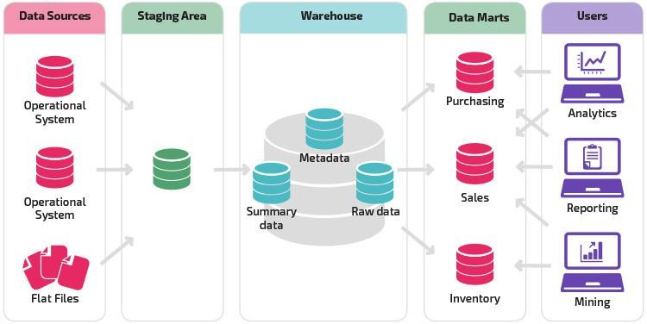

Big Data Storage Structure -
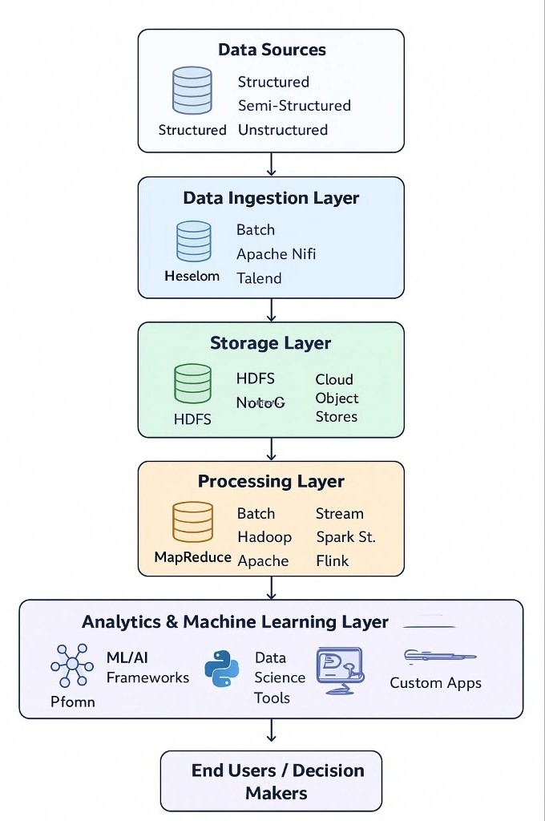

Difference Between Data Warehouse and Big Data Systems

Aspect | Data Warehouse | Big Data Systems (Hadoop, Spark, etc.)
Type of Data | Structured (rows/columns, relational tables). | Handles structured, semi-structured (JSON, XML), and unstructured (videos, images, logs).
Data Volume | Terabytes (TBs) scale, limited scalability. | Petabytes (PBs) or more, highly scalable.
Data Source | Cleaned, processed, historical data (ETL before loading). | Raw, real-time, and streaming data (logs, events, social media).
Processing | Mainly Batch (queries on stored data). | Both Batch (Hadoop) and Real-Time (Spark Streaming, Flink).
Storage | Relational DBs (Oracle, SQL Server, Teradata). | Distributed file systems (HDFS, AWS S3, GCP Cloud Storage).
Query Language | SQL (structured query language). | HiveQL, Spark SQL, NoSQL, custom APIs.
Performance | Optimized for complex queries on smaller datasets. | Optimized for massive datasets; performance depends on cluster size.
Hardware | Usually runs on expensive, high-performance servers. | Runs on commodity hardware clusters (cost-effective scaling).
Use Case | Business reporting, dashboards, finance, compliance. | Real-time analytics, machine learning, recommendation engines.

Netflix Example | - Billing system and subscription churn reports are stored in Data  Warehouse. | - Streaming logs, recommendations, real-time “Top 10 in India” use Big Data  systems.

Benefits of Big Data
  - Netflix saves $1B+ annually by reducing churn through recommendations.

  - Helps predict new hit shows before launch.

  - Improves network reliability → better user experience.

  - Visual: Pie chart → Revenue Growth, Customer Retention, New Insights.

Section 3 – Querying & Analysis

Marketing Data Sources
  - Netflix gathers marketing data from:

    - Social media trends.

    - Ad campaign engagement (clicks, conversions).

    - Watch time after a trailer release.

  - Visual: Funnel → Ads → Clicks → Netflix Signups.

  - Class Activity: “Why might a show trend in India but flop in the US?”

How Big Data Proved Its Benefits

  - Example: House of Cards success was data-driven.

    - Users liked Kevin Spacey.

    - Political dramas were trending.

    - David Fincher had a loyal audience base.

  - Visual: Poster with arrows pointing to “Data Insights → Decision → Production.”

Data Storage & Analysis at Netflix
  - Storage: AWS S3 houses petabytes of Netflix data.

  - Analysis Tools: Spark + Presto for large-scale analytics.

  - Visual: Pipeline diagram → Logs → Storage → Spark → Dashboards
📡 Step 1: Source Systems (Upstream Data Producers)
Data originates from multiple places:

Databases (Structured)

    - SQL Server, Oracle, PostgreSQL

    - Example: Orders table (transactions of an e-commerce site).

APIs (Semi-structured / JSON)

    - Jira API, Azure DevOps API, Salesforce API

    - Example: Pulling ticket status from Jira for project metrics.

Files (Structured / Semi-structured)

    - CSV, Excel, JSON, XML

    - Example: Monthly product returns uploaded in Excel.

Platforms & Logs (Semi-structured / Unstructured)

    - SharePoint, IoT Devices, Web Portals, Clickstream logs

    - Example: IoT sends sensor data every 5 seconds.

⚡ Key Interview Qs:
- What are the sources (DB, API, flat files)?

- What formats (structured/semi-structured/unstructured)?

- Who owns each source system?

📥 Step 2: Data Ingestion
Once sources are identified, data must be ingested into a central platform.

Ingestion Methods:

Batch Processing

    - Data loaded on schedule (e.g., once daily at 2 AM).

    - Example: Daily sales report from Oracle DB → Data Lake.

Streaming (Real-Time) Processing

    - Data flows continuously (seconds latency).

    - Example: Netflix showing “Similar Recommendations” after watching Squid Game.

Tools:
  - Azure Data Factory (ADF) – Batch pipelines from DBs/APIs → Data Lake.

  - Kafka – Distributed queue for event streaming.

  - Airbyte / Fivetran – No-code ingestion for SaaS apps.

⚡ Key Interview Qs:
- What’s the ingestion frequency (real-time, hourly, daily)?

- What is the data volume per batch/day?

🗂 Step 3: Storage Layer (Data Lake – Bronze Layer)

📦 Data Lakes (Cloud Storage):
  - Azure Data Lake (ADLS) – Microsoft’s solution.

  - Amazon S3 – Amazon’s object storage.

Bronze Layer:
  - Stores raw ingested data as-is (no transformations).

Retains original format (CSV, JSON, Parquet, Avro).

  - Example: API JSON dump from Jira is stored untouched in Bronze.

⚡ Best Practice: Always log schema + ingestion metadata.

⚙ Step 4: Data Transformation (Silver Layer)
This stage involves cleaning and structuring the raw data.

Common Steps:
  - Remove duplicates / nulls

  - Standardize data types (e.g., date → YYYY-MM-DD)

  - Apply business filters (exclude test records)

  - Join with reference tables (e.g., product hierarchy)

Tools:
  - PySpark (for distributed transformations)

  - Delta Tables (ACID compliance + versioning)

Example:

  - From Jira JSON dump (Bronze) → Extract ticket fields (id, status, assignee).

  - Save cleaned dataset into Silver Layer (Delta Table).

⚡ Key Interview Qs:
- How do you handle schema drift?

- What business rules/filters are applied here?

🏆 Step 5: Data Modeling (Gold Layer)
Now data is enriched, aggregated, and modeled for consumption.

Medallion Architecture:
  - Bronze – Raw

  - Silver – Cleaned, structured

  - Gold – Business-ready

Modeling Concepts:
  - Fact Tables (metrics → sales, orders, revenue)

  - Dimension Tables (descriptions → product, customer, time)

Schema Types:
  - Star Schema (Fact + Dimensions, simple, fast)

  - Snowflake Schema (normalized dimensions, more detail)

Example:

  - Fact: Sales (order_id, product_id, revenue, date_key)

  - Dim: Customer (cust_id, name, location)

  - Dim: Product (product_id, category, brand)

⚡ Key Interview Qs:
- Do you need historical tracking (SCD Type 2)?

- Which schema (Star/Snowflake) is best for your BI use case?

🧮 Step 6: OLTP vs OLAP Separation
  - OLTP (Transactional DBs) – Handles real-time transactions (insert/update/delete).

    - Example: Banking system recording each ATM withdrawal.

  - OLAP (Data Warehouse / Lakehouse) – Optimized for aggregations & analytics.

    - Example: Dashboard showing monthly revenue trends.

⚡ Rule of Thumb: OLTP = Operations, OLAP = Insights.

📊 Step 7: Reporting & Consumption Layer
Once Gold Layer tables are built → they are exposed to BI & ML teams.

  - SQL Views on Gold Tables → datasets.

  - BI Tools – Power BI, Tableau, Domo.

  - ML Models – Use curated datasets for predictions.

Example Flow:

  - Gold Table (Sales) → SQL View (Sales_Last_12_Months) → Power BI Dashboard (Revenue Trend).

⚡ KPIs for E-commerce:
  - Sales: Revenue, Avg. Order Value, Orders/day

  - Returns: Return rate, Top reason codes

  - Customer: LTV, Retention rate

  - Marketing: ROI, CAC

  - Site Performance: Cart abandonment %, Session duration

🔐 Security & Governance
  - Azure Key Vault / AWS Secrets Manager → Manage API keys, DB creds.

  - Data Quality Checks – Null %, Duplicate %, Business rules.

  - Data Lineage – Track transformations across Bronze → Silver → Gold.

📁 Project-Level Example (DRE – Data Reporting Engine)

Data Sources:

  - Jira API, DevOps API, SharePoint Files

Services Used:
  - Azure Key Vault – Secure creds

  - ADF – Pipelines for ingestion

  - ADLS – Bronze/Silver/Gold layers

  - PySpark – Transformations & aggregations

  - Delta Tables – Reliable storage with versioning

Output:
  - SQL Views → Published Datasets → Power BI Dashboards

🔁 Final End-to-End Flow
flowchart TD
A[Source Systems: Jira, DevOps, SharePoint] --> B[Azure Key Vault (Secure Credentials)]
- --> C[Azure Data Factory (ETL Pipelines)]
- --> D[ADLS Bronze Layer (Raw Data)]
- --> E[PySpark Jobs (Cleaning + Validation)]
- --> F[ADLS Silver Layer (Structured Data)]
- --> G[PySpark Business Logic, Joins, Aggregations]
- --> H[ADLS Gold Layer (Modeled Tables - Delta)]
- --> I[SQL Views / Datasets]
- --> J[Power BI / Tableau / ML Models]

